**V-Model**

The V-model is an SDLC model where execution of processes happens in a sequential manner in a V-shape. It is also known as **Verification and Validation model**.

The following illustration depicts the different phases in a V-Model of the SDLC.

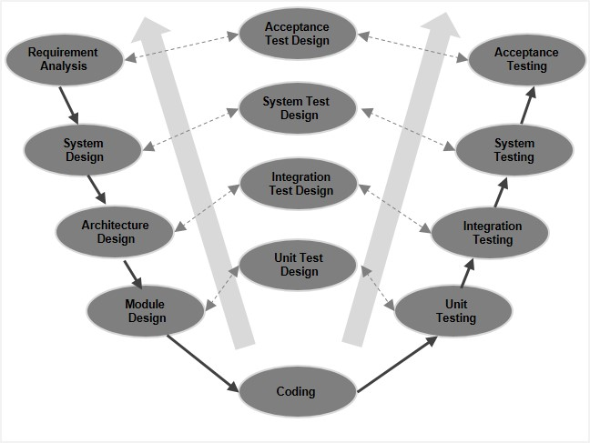

## **V- Model ─ Application**

The following pointers are some of the most suitable scenarios to use the V-Model application.

* Requirements are well defined, clearly documented and fixed.
* Product definition is stable.
* Technology is not dynamic and is well understood by the project team.
* There are no ambiguous or undefined requirements.
* The project is short.

The advantages of the V-Model method are as follows −

* This is a highly-disciplined model and Phases are completed one at a time.
* Works well for smaller projects where requirements are very well understood.
* Simple and easy to understand and use.
* Easy to manage due to the rigidity of the model. Each phase has specific deliverables and a review process.

The disadvantages of the V-Model method are as follows −

* High risk and uncertainty.
* Not a good model for complex and object-oriented projects.
* Poor model for long and ongoing projects.